Chapter 8, Problem 56.

In the circuit of Fig. 8.102, find i(t) for t > 0.

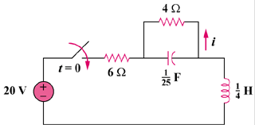

Figure 8.102
For Prob. 8.56.

